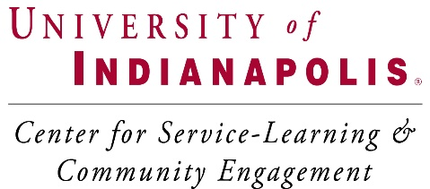

Guidelines for Writing a
Memorandum of Understanding (Toolkit)

Assistant Dean, Interdisciplinary Studies & Service Learning
Components of a Memorandum of Understanding | Write your responses to the questions below. Your responses will build the foundation for the Memorandum of Understanding.
What key agencies are involved in the project? Members of the campus community? Third party organizations or agencies?
What is address of organization?
(As a reminder, please provide project dates and project location with the UIndy campus police.)
What is the name and contact information of the key contact person at organization?
What is the historical legacy that has existed between the community and campus?
What are the collaboration’s purpose, goals and objectives?
What are each organization’s expectations and anticipated benefits of the collaboration? (i.e., faculty, community, and student)
What are the roles, responsibilities and key tasks of each organization? How are these roles identified? Do they reflect the strengths and assets of each organization?
What is the timeline for small and large milestones?
How might community organizations and representatives from the campus work together to address them?
What are the organization’s outcomes?
Whose financial resources will contribute to the organization’s activities?
How will all stakeholders be oriented to the organization’s activities? For example, how will students be oriented to the community agency and vice versa?
How will fundraising activities be carried out (i.e., grant-writing, etc.)? Who will be responsible for identifying funding opportunities and developing proposals for funding?
What resources will be allocated to the collaborative activities? List these resources.
What are the anticipated organization’s products, and how will the copyright and ownership issues be addressed?
What is the organization’s evaluation plan of its work and how will the findings be used?
How will students be supervised?
How will students’ service activities be monitored?
How often will supervisors/faculty meet with students to review progress?
What is the organization’s “feedback” strategy and agreed upon ways to address agency’s concerns and achievements?
What is the organization’s marketing and publicity plan?
What is the process for sharing information with the community and campus about relevant research findings produced from the organization’s activities?
What is the process for determining authorship? For example, if articles are written about research findings how will authors be identified and cited?
How will the organization share credit and celebrate success? How often will celebratory events take place?
How will the collaboration ensure the inclusion of culturally competent approaches in the Service Learning activities?
What is the process for determining if the collaboration will continue? What might be the conditions or criteria under which the collaboration might choose to dissolve?
What is the organization’s risk management plan? Will the student receive an orientation that includes safety information?
Does the organization have insurance?
Will the organization expect students to drive as a part of their work?
Will student be operating any heavy or dangerous equipment?
What emergency procedures are in place to protect students, faculty, and community representatives?
Other:
Other:
Other:

